Name
Ronald P. Toby

Position/Title/Affiliation
Professor Emeritus, EALC & History

Bio:

Research Interests:
Premodern Japanese history & culture
Early-modern Korean-Japanese relations
History of Japanese cartography
Visual history
Images of the Other in early modern Japanese popular culture

Education:
B.A. Columbia University, 1965
M.A. Columbia University, 1974
Ph.D. Columbia University, 1977

Awards:
2012 National Institutes for the Humanities Prize in Japanese Studies.
2006 Outstanding Graduate Mentorship Award, University of Illinois.
1993 Japan Society for the Promotion of Science Senior Research Fellowship.
1989-90 Japan Foundation Professional Fellowship.
1988-89 National Endowment for the Humanities Senior Fellow.
1987-88 LAS Faculty Fellow in a Second Discipline (Anthropology), UIUC.
1986-89 University Scholar of the University of Illinois.
1984-85 Fulbright-Hays Faculty Research Fellowship.

Courses taught:
No longer teaching

Selected publications:
Books:
Forthcoming Engaging the Other: ‘Japan’ and Its Alter-Egos, 1550-1850 (Brill).
2011 Ezu-gaku nyūmon (Introduction to Early Modern Mapping). Co-editor with Sugimoto Fumiko et al. (University of Tokyo Press).
2008 ‘Sakoku’ to iu gaikō (The politics of ‘seclusion’), vol. 9 of Nihon no rekishi (Shōgakukan).
2007 Japan and Its Worlds: Marius Jansen and the Internationalization of Japanese History. Co-editor, with Martin Collcutt & Mikio Kato (I-House Press).
2004 Emergence of Economic Society in Japan, 1600-1859. Co-editor with Akira Hayami & Osamu Saitō (Oxford University Press).
2004 Nik-Kan-Chū no kōryū: hito-mono-bunka (Japanese-Korean-Chinese exchange: people, objects, culture), with Yoshida Mitsuo et al.; ed., Yoshida Mitsuo (Yamakawa Shuppansha).
2002 Kanryū suru bunka to bi (Culture in circulation). Co-edited with Aoyagi Masanori (Kadokawa Shoten).
1994 Gyōretsu to misemono (Parades and shows). With Kuroda Hideo (Asahi Shinbunsha).
1984 State and Diplomacy in Early Modern Japan: Asia in the Development of the Tokugawa Bakufu (Princeton University Press).
Selected Articles & Chapters:
2016 “Kanō Masunobu-hitsu Chōsen shisetsu kantai-zu byōbu no kaiga retorikku,” (The pictorial rhetoric of Kanō Masunobu’s “Korean Embassy Reception Screens”), tr. Matsushima Jin, in Kokka (Japanese art history), 121.6 (Feb.) : 9-25.
2015 “Chōsen tsūshinshi no Edo-jō tōjō gyōretsu,” in Kurushima Hiroshi, ed., Egakareta gyōretsu: bushi, ikoku, sairei (University of Tokyo Press).
2008 “Kinsei no miyako meisho: Hōkōji to Mimizuka” (Tourist attractions in early modern Kyoto: Hōkōji Temple and the Ear Mound), in Rekishigaku kenkyū (Historical studies), 841 (July): 1-12.
2007 “The Originality of the ‘Copy’: Mimesis and Subversion in Hanegawa Tōei’s Chōsenjin ukie,” in Rupert Cox, ed., Cultures of Copying in Japan (Routledge/Japan Anthropology Workshop Series).
2007 “Foreign Texts/Native Readings: Matsushita Kenrin (1637-1703) & the Challenge of Chinese/Korean Histories,” in Toby et al., ed. Japan and Its Worlds, pp. 113-155.
2003 “Kinsei shotō tai-Min no ichi gaikō monjo shohon no keifu: gosha, godoku, goki no keifu to Nihon-gata ka’i ron” (Text genealogy of an early Edo-period diplomatic letter to Ming: mistranscription, misreading, miswriting and the notion of Japanese centrality), in Shiryō Hensanjo kenkyū kiyō, 13: 60-81.
2003c “Kusumi Morikage hitsu Chōsenjin gyōretsu-zu byōbu ni tsuite” (On Kusumi Morikage’s Korean Parade Screens), in Kokka (Japanese art history), 109.5: 5-16.
2002 “Kan-Nihonkai no Fugaku enbō” (Distant sightings of Mt. Fuji around the Sea of Japan), in Toby & Aoyagi ed., Kanryū suru bunka to bi (Kadokawa Shoten): 144-162.
2001 “Three Realms/Myriad Countries: An ‘Ethnography’ of Other and the Re-Bounding of Japan, 1550-1750,” in Constructing Nationhood in Modern East Asia, ed. K. Chow, K. M. Doak, & P. Fu (Michigan): 15-45.
2001 “Rescuing the Nation from History: The State of the State in Early-modern Japan,” in Monumenta Nipponica, 56.1: 197-237.
1998 “Imagining and Imaging ‘Anthropos’ in Early-modern Japan,” in Visual Anthropology Review, 14.3: 19-44.
1994 “The Indianness of Iberia and Changing Japanese Iconographies of Other,” in Implicit Understandings: Observing, Reporting, and Reflecting on the Encounters between Europeans and Other Peoples in the Early Modern Era, ed. Stuart Schwartz (Cambridge): 323-351.
1991b “Both a Borrower and a Lender Be: From Village Moneylender to Rural Banker in the Tempo Era,” in Monumenta Nipponica, 46, 4 (Winter): 483-512.
1985a “Contesting the Centre: International Sources of Japanese National Identity,” in The International History Review, 7.3: 347-363.
1985b “Why Leave Nara? Kanmu and the Transfer of the Capital,” in Monumenta Nipponica, 40.3: 331-347.
1977a “Shoki Tokugawa gaikō ni okeru ‘sakoku’ no ichizuke: bakufu seitōsei kakuritsu o chūshin ni,” in Edo jidai no atarashii shizō o motomete, ed., Shakai Keizai-shi Gakkai, (Tōyō Keizai Shinpōsha): 21-39.
1977b “Reopening the Question of Sakoku: Diplomacy in the Legitimation of the Tokugawa Bakufu,” Journal of Japanese Studies, 3.2: 323-364. (revised version of 1977a0

Museum Exhibitions

2012 Co-Curator, “Parades in Early Modern Japan,” National Museum of Japanese History, Sakura City, Japan, October-December 2012.
2010— Co-Curator, Standing Exhibit on Early Modern Japan, National Museum of Japanese History, Sakura City, Japan.
2006-07 Guest Curator, “Alien Images: Foreigners in Japanese Prints, 17th-19th Century,” Art Institute of Chicago, January-April 2007.
2003-04 Guest Curator, “Picturing Performance: Japanese Theater Prints of the Utagawa School, 1790-1868,” Krannert Museum of Art, University of Illinois, January-March 2004.

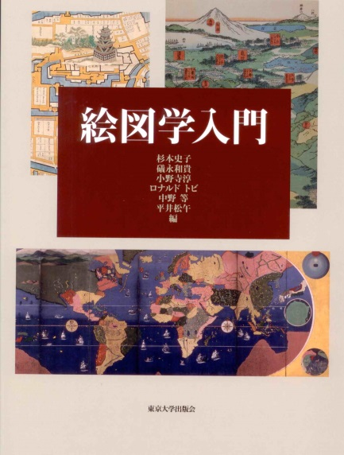
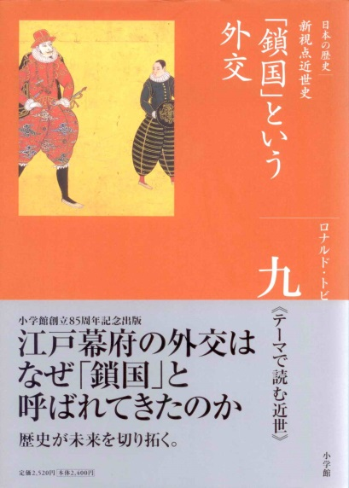
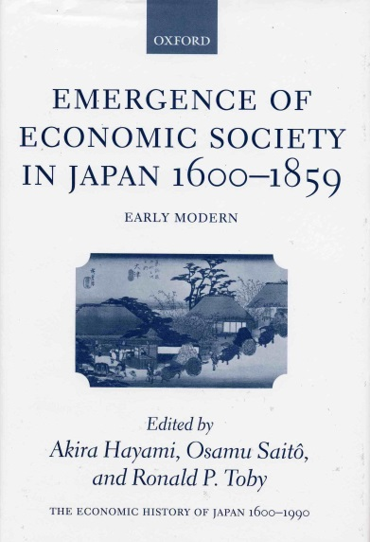
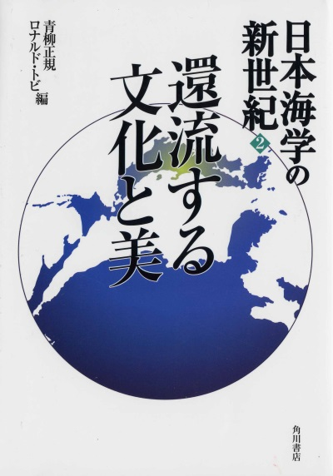
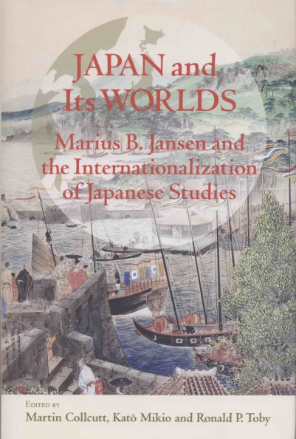
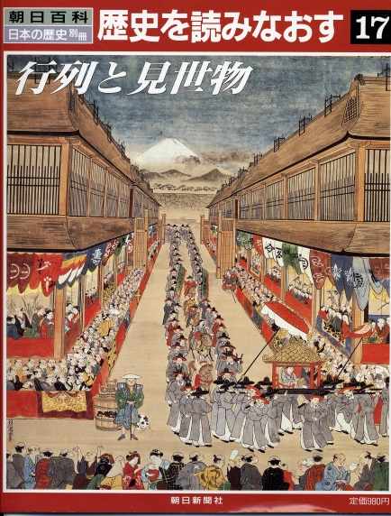
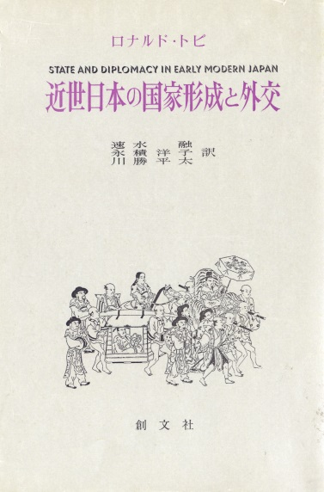
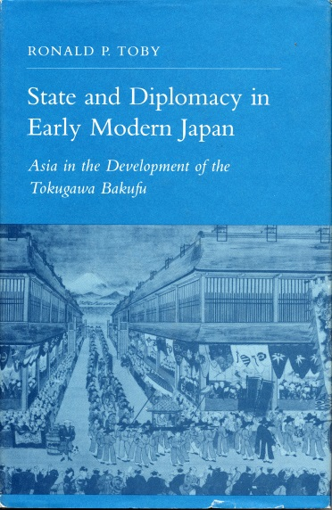
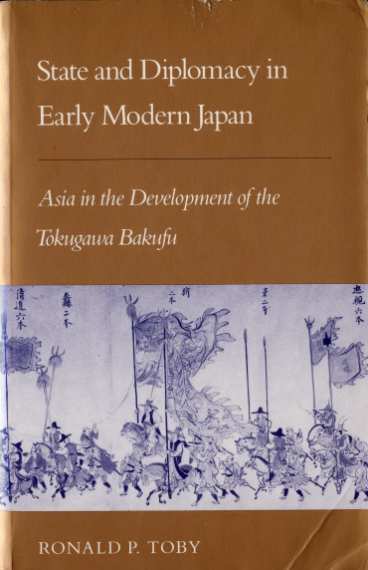
(Optional: Photos of book covers + links to publishers or retailers)

